**Ideation Phase**

**Define the Problem Statements**

|  |  |
| --- | --- |
| Date | 18-06-2025 |
| Team ID | LTVIP2025TMID49405 |
| Project Name | Measuring the Pulse of Prosperity: An Index of Economic Freedom Analysis |
| Maximum Marks | 2 Marks |

**Customer Problem Statement Template:**

Create a problem statement to understand your customer's point of view. The Customer Problem Statement template helps you focus on what matters to create experiences people will love.

A well-articulated customer problem statement allows you and your team to find the ideal solution for the challenges your customers face. Throughout the process, you’ll also be able to empathize with your customers, which helps you better understand how they perceive your product or service.

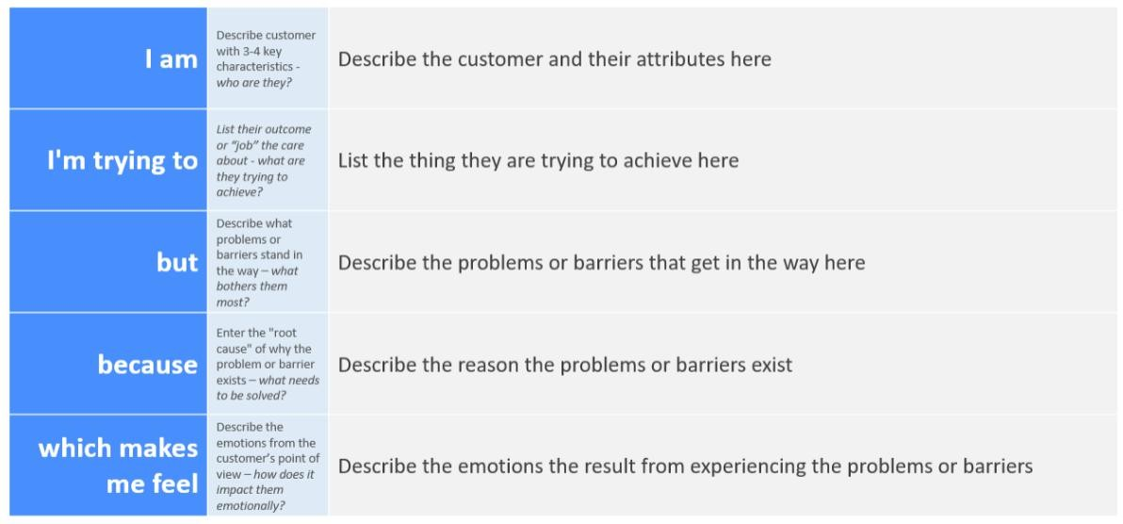

Reference: <https://miro.com/templates/customer-problem-statement/>**Example:**

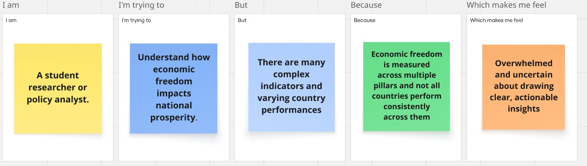

|  |  |  |  |  |  |
| --- | --- | --- | --- | --- | --- |
| **Problem**  **Statement (PS)** | **I am**  **(Customer)** | **I’m trying to** | **But** | **Because** | **Which makes me feel** |
| PS-1 | Policy  maker /  Governmen  t official | Improve economic policy decisions | Lack of consolidated and easy-tounderstand data on economic freedom  pillars | Lack of consolidated and easy-tounderstand data on economic freedom pillars | Frustrated and uncertain |
| PS-2 | Researcher / Economist | Analyze factors affecting economic growth | Data comparison between  countries is complex | Economic freedom  indicators are scattered and unstandardized | Overwhelmed and delayed |